**EVALUATION QUESTION-- Design a system with two buttons such that a. Red light when any button is pressed during night. b. Green light when both buttons are pressed during night.CIRCUIT DIAGRAM-**

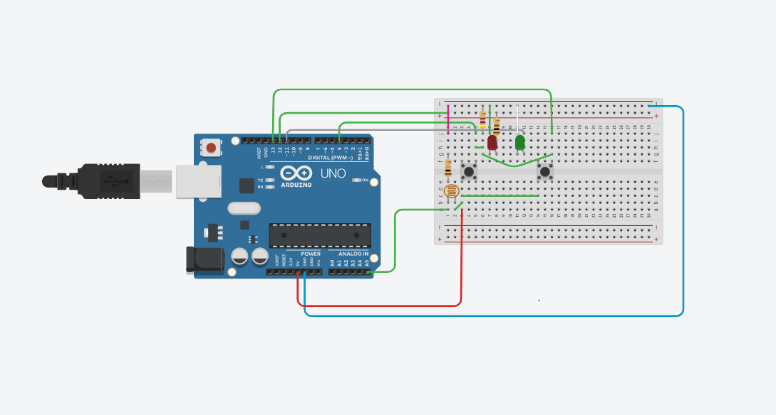

**CONCEPT USED-** USAGE OF SWITCH, PHOTORESISTOR.

**LEARNING AND OBSERVATION-** WE CAN EASILY MANUPLATE SIMPLE CONCEPTS INTO SOMETHING THAT IS BOTH PROFITABLE IF SOLD AS A PRODUCT AND SIMPLE COMPONENTS CAN RESULT INTO SOMETHING WONDERFUL IF COMBINED WITH A GOOD CODE.

**CODE-**

